While Loop Worksheet Name:

1)

int MAX = 20;

int num = 13;

while(num < MAX)

{

System.out.println(num);

num = num + 2;

}

System.out.println(num);

13

15

17

19

21

2)

int i = 53;

while(i > 6)

{

System.out.println(i);

i = i/2;

}

System.out.println(i);

53

26

13

6

3)

int i = 100, j=2;

while(i >= 1)

{

System.out.println(i%j);

i-=15;

j++;

}

System.out.println(“i is “+ i);

System.out.println(“j is “+ j);

0

1

2

0

4

4

2

i is -5

j is 9

4) Trace the following loops. Display the output. Write “runtime error”, “compile time error” or “infinite loop” where appropriate.

a)

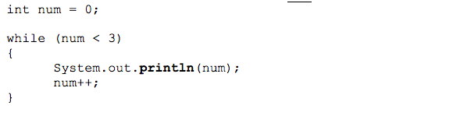

0

1

2

b)

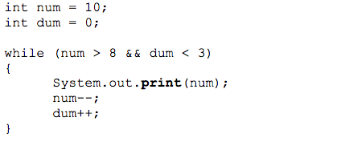

109

c)

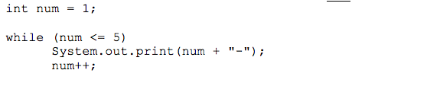

runtime error (infinite loop)

d)

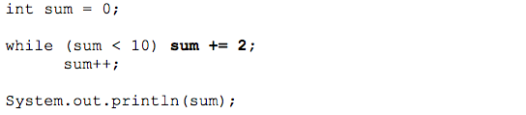

11

e)

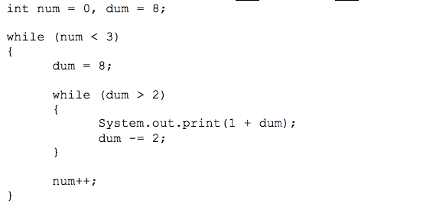

**975975975**

**5. While Loop Simulation**  
For each call of the method below, write the output that is printed:

public static void mystery(int i, int j) {

while (i != 0 && j != 0) {

i = i / j;

j = (j - 1) / 2;

System.out.print(i + " " + j + " ");

}

System.out.println(i);

}

Method Call Output

mystery(5, 0); _______5__________

mystery(3, 2); _______1 0 1____________

mystery(16, 5); _____3 2 1 0 1_________

mystery(80, 9); ______8 4 2 1 2 0 2_______

mystery(1600, 40); _______40 19 2 9 0 4 0

**6. While Loop Simulation**For each call of the method below, write the output that is produced:

public static void mystery(int a, int b) {

while (b != 0) {

if (a > b) {

System.out.print(a + " ");

a = a - b;

} else {

System.out.print(b + " ");

b = b - a;

}

}

System.out.println(a);

}

|  |  |
| --- | --- |
| Method Call | Output |
| mystery(42, 0);  mystery(6, 12);  mystery(18, 27);  mystery(24, 60);  mystery(50, 15); | ______42________  ______12 6 6____________  ______27 18 9 9____________  ____60 36 24 12 12__________  _________50 35 20 15 10 5 5________ |